**Welcome to Algebra II**

**Welcome!** My name is Austin Sanchez and I will be finishing out the school year as your Algebra II teacher. I know it can be stressful to have a new teacher come in halfway through the year, but between myself and the GTCHS staff, we will make the transition smooth. I am extremely excited for this opportunity and am looking forward to teaching and spreading my joy of math with you.

**Items you will need…**3 ring binder with notebook and graph paper (**no** spiral notebooks please)  
Pencils, colored pencils, and dry erase markers  
TI-83 or TI-84 graphing calculator – you will need one for homework. (check out ebay)  
  
**How to study…(This is essential for success in Algebra II)**  
Each night when you complete your homework, you need to go back to the section that was done the class period before and work a few of each type of problem. Just spend 10-15 minutes doing this. If you have trouble, you need to see me the very next day for help.

**Help…**I am working on having a calendar on my website to keep you up to date and that way you know what is going on in the future. Office hours will be offered on Thursday after school in Room 213 from 2:45-3:30. I will also be setting up a remind account where you will get updates and will be able to ask questions. You can also email me.

**Grading…**

Tests 35% Spiral 15% Homework 10%  
Quizzes 25% TBD 15%  
Mid-term and Final exams are 10% of the respective semester average.  
  
Homework…  
  
Homework will be given every night. Work that is sent home on new material will be graded for completion. For Example, if there are 25 problems and a student completes 20, he/she will receive a grade of 20/25 (80%) for that assignment. Work that is sent home on old material based on prior knowledge will be graded for accuracy.

Consequences for not having homework…  
A zero will be entered into the gradebook. I do not take late homework. After three missed assignments, I will call/email home.

**Mastery learning…**

As we are a mastery learning school, students will have the opportunity in Algebra II to do test corrections on any test that has a grade below an 80. All test corrections will be done after school during office hours. Students must correct EVERY problem that was missed and will earn half credit back for a maximum grade of 80.

**Classroom Rules…**  
1. Bring all materials (Book, notebook, pencil, calculator) to every class.  
2. Be in your seat ready to work by the time the bell rings.   
3. No passes will be given out of class. Take care of bathroom needs between classes.  
4. Respect everyone in the classroom. Disrespect of any kind will not be tolerated.  
5. All missed tests/quizzes must be made up within 2 weeks of returning to school. A grade of zero will be entered until the work is made up.

**Consequences…**

1. Warning  
2. Detention before school and a call home  
3. Referral and a call home

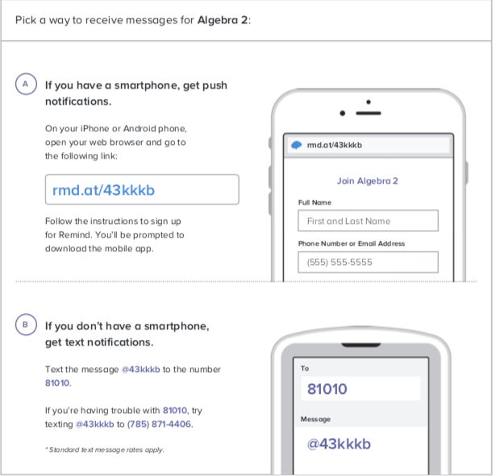**Website** https://www.gtchs.org/site/Default.aspx?PageID=368  
  
**How to reach me…**  
Email: asanchez@staff.gtchs.org   
Remind: All students and parents should sign up for my Remind messages. I send messages to remind students about major tests and quizzes.